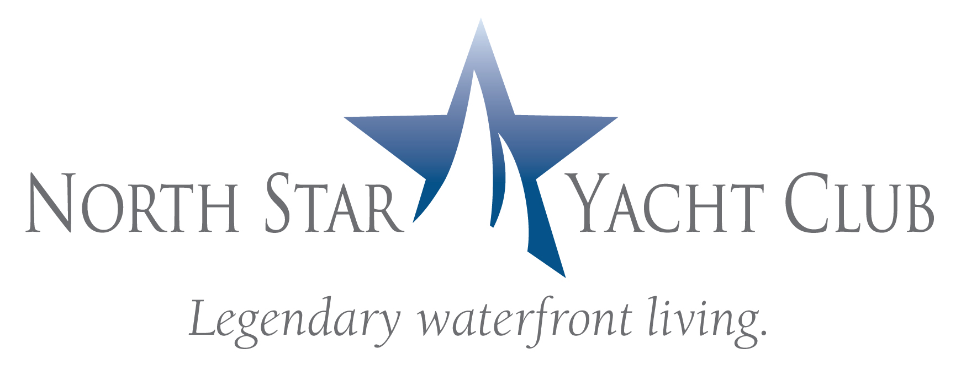
FOR IMMEDIATE RELEASE
POOLSIDE CABANAS ENHANCE WATERFRONT LIVING
AT NORTH STAR YACHT CLUB
NORTH FORT MYERS, Fla. (February 4, 2009) – North Star Yacht Club announced the completion of their new cabana model, representing 16 poolside cabanas offered by North Star Yacht Club designed to provide residents with upscale waterfront living at substantial value.
The twin 12-story waterfront high rises with penthouse level located along the Caloosahatchee River in North Fort Myers offer residents a myriad of indoor and outdoor amenities, activities and services including an expansive clubhouse with theater, health club, business center, and resort-style pool. The 12-acre property also boasts a private marina walk and adjoining boat slips. Residences at North Star Yacht Club start at $307,900.
The new 196-square-foot, air-conditioned cabanas offer a private retreat from the sundeck with views of the pool through expansive sliding glass doors. Inside each cabana, there is a full bath, closet and kitchenette complete with refrigerator, sink and microwave. Constructed with the great room concept in mind, the central living area provides ample space for an intimate living room and dining area. The cabanas are priced at $69,900.
Prospective homeowners are invited to visit North Star Yacht Club to view four newly designed model homes that represent the floor plans for the luxury waterfront condominiums, plus the opportunity to see the amenities and the new cabanas.
North Star Yacht Club is located at 3420 Hancock Bridge Parkway in North Fort Myers. The sales center and model residences are open Monday through Friday from 10:00 a.m. to 6:00 p.m., Saturday from 10:00 a.m. to 5:00 p.m., and Sunday noon to 5:00 p.m. For more information, call (239) 995-8200 or visit www.NorthStarYachtClub.com.
The exclusive sales and marketing agent for North Star Yacht Club, The Marketing Directors, LLC, is based in Atlanta, GA and was founded in 2007 by national condominium expert, David Tufts. He and Adrienne Albert, Marketing Directors, Inc’s Chief Executive Officer collaborated to create a team of the most highly experienced real estate professionals in the Southeast to service developers specializing in high density residential sales and marketing. With over 30 years of experience, The Marketing Directors is well positioned to be the solution to developers in any market condition. The Marketing Directors, LLC represents developers in Atlanta, Orlando, Tampa, West Palm Beach St Petersburg, Chapel Hill, and Huntsville.

(cutline for photo)
A Poolside Retreat
Recently completed at North Star Yacht Club: a cabana model representing 16 air-conditioned, poolside cabanas complete with full bath, closet, kitchenette and ample space for an intimate living room and dining area.
