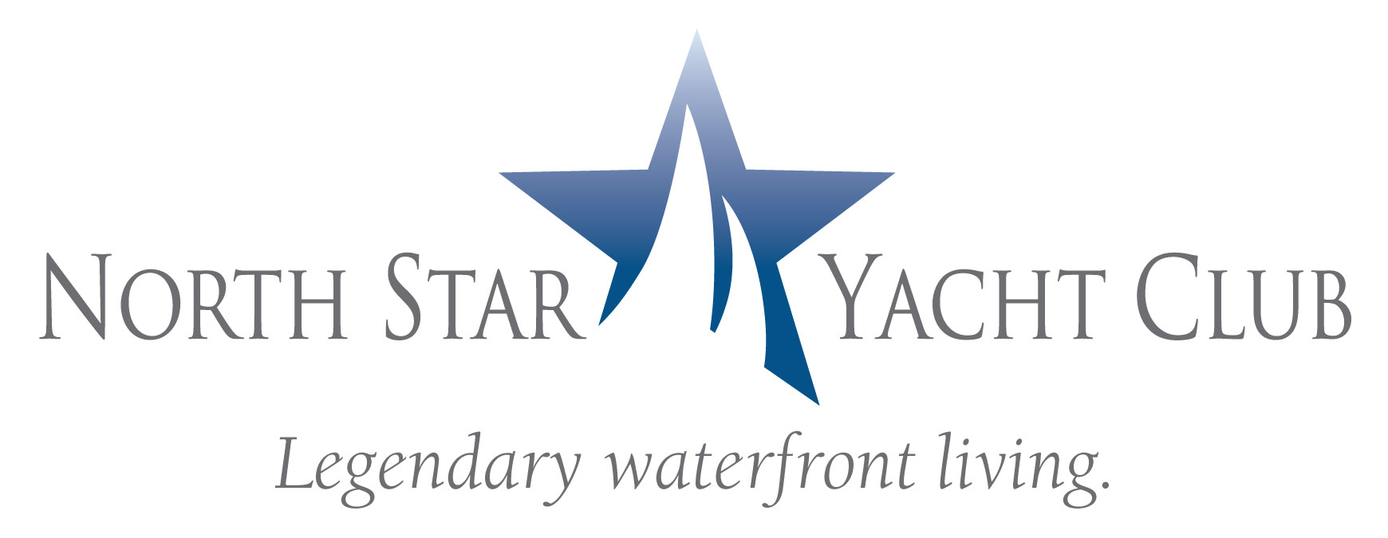

Contact: Shahn Douglas
Senior Vice President, Marketing
The Marketing Directors, LLC
407.487.1881

FOR IMMEDIATE RELEASE

NORTH STAR YACHT CLUB PARTNERS WITH
SW FLORIDA SYMPHONY SOCIETY
Downtown High-Rise to Host Fundraiser Kick-off

NORTH FORT MYERS, Fla. – (December 19, 2008) – North Star Yacht Club, twin 12-story high rises with penthouse level located along the Caloosahatchee River in North Fort Myers, is orchestrating an event with the Southwest Florida Symphony Society to launch its Divine Dream Drawing fundraiser on Thursday, January 8, 2009 from 5 to 7 p.m.

The event is open to the community and tickets cost $10 per person which includes cocktails, hors d’oeuvres and live music by members of the Symphony. Guests will also have an opportunity to view the amenities and waterfront condominium models.

North Star Yacht Club offers an upscale lifestyle where residents have exclusive access to a myriad of indoor and outdoor amenities, activities and services including an expansive clubhouse with theater, health club, business center, and resort-style pool. The 12-acre property also boasts a private marina walk and adjoining boat slips. Waterfront condominiums are offered from $307,900.

“North Star Yacht Club is delighted to partner with the Symphony Society and applauds their contributions to our cultural community,” said Shahn Douglas, Senior Vice President Marketing, The Marketing Directors, LLC.

North Star Yacht Club is located at 3420 Hancock Bridge Parkway in North Fort Myers. The sales center and model residences are open Monday through Friday from 10:00 a.m. to 6:00 p.m., Saturday from 10:00 a.m. to 5:00 p.m., and Sunday noon to 5:00 p.m. For more information, call (239) 995-8200 or visit www.NorthStarYachtClub.com.

For more information on the Divine Dream Drawing Event or the Southwest Florida Symphony Society, call Jane Hudson at (239) 995-0796.

The Marketing Directors, LLC, based in Atlanta, GA was founded in 2007 by national condominium expert, David Tufts. He and Adrienne Albert, Marketing Directors, Inc’s Chief Executive Officer collaborated to create a team of the most highly experienced real estate professionals in the Southeast to service developers specializing in high density residential sales and marketing. With over 30 years of experience, The Marketing Directors is well positioned to be the solution to developers in any market condition. The Marketing Directors, LLC represents developers in Atlanta, Orlando, Tampa, West Palm Beach St Petersburg, Chapel Hill, and Huntsville.

####

