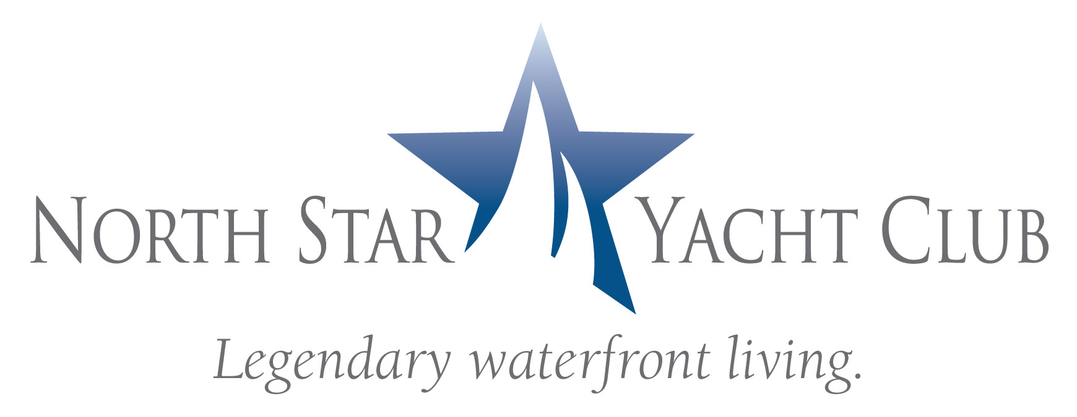

Contact: Phyllis Ershowsky
PKE Marketing & PR Solutions
239.565.5996

FOR IMMEDIATE RELEASE

SW FLORIDA SYMPHONY FUNDRAISER KICKS OFF AT
NORTH STAR YACHT CLUB

NORTH FORT MYERS, Fla. – (January 12, 2009) – North Star Yacht Club, twin 12-story high rises with penthouse level located along the Caloosahatchee River in North Fort Myers, was the venue on January 8th for an event with the Southwest Florida Symphony Society to launch its Divine Dream Drawing fundraiser.

More than Symphony Society members and guests enjoyed wine, hors d’oeuvres and live music by members of the Symphony.

North Star Yacht Club offers an upscale lifestyle where residents have exclusive access to a myriad of indoor and outdoor amenities, activities and services including an expansive clubhouse with theater, health club, business center, and resort-style pool. The 12-acre property also boasts a private marina walk and adjoining boat slips. Waterfront condominiums are offered from $307,900.

North Star Yacht Club is located at 3420 Hancock Bridge Parkway in North Fort Myers. The sales center and model residences are open Monday through Friday from 10:00 a.m. to 6:00 p.m., Saturday from 10:00 a.m. to 5:00 p.m., and Sunday noon to 5:00 p.m. For more information, call (239) 995-8200 or visit www.NorthStarYachtClub.com.

For more information on the Southwest Florida Symphony Society, call Jane Hudson at (239) 995-0796.

The Marketing Directors, LLC, based in Atlanta, GA was founded in 2007 by national condominium expert, David Tufts. He and Adrienne Albert, Marketing Directors, Inc’s Chief Executive Officer collaborated to create a team of the most highly experienced real estate professionals in the Southeast to service developers specializing in high density residential sales and marketing. With over 30 years of experience, The Marketing Directors is well positioned to be the solution to developers in any market condition. The Marketing Directors, LLC represents developers in Atlanta, Orlando, Tampa, West Palm Beach St Petersburg, Chapel Hill, and Huntsville.

####
(cutlines for photos)
- North Star Yacht Club was the venue for the Southwest Florida Symphony Society event on January 8, 2009. From left to right: Chuck Ryder, Jim Edmire, Carla Ryder and Carol Edmire.
- From left to right: Bonnie Potter, Shirley Trinski, Valerie Lynn and Janet Forrer.
- From left to right: Muriel Pfeiffer and Estellita Rainwater-August.
- Thelma Gunter and Shirley Marsh
- Dot Geall and Jackie Kohls
- Jerry Witstadt, Ed Ripperger and Wayne Geall
- Carol Edmire, Christine LaCroix and Sue McLaughlin

