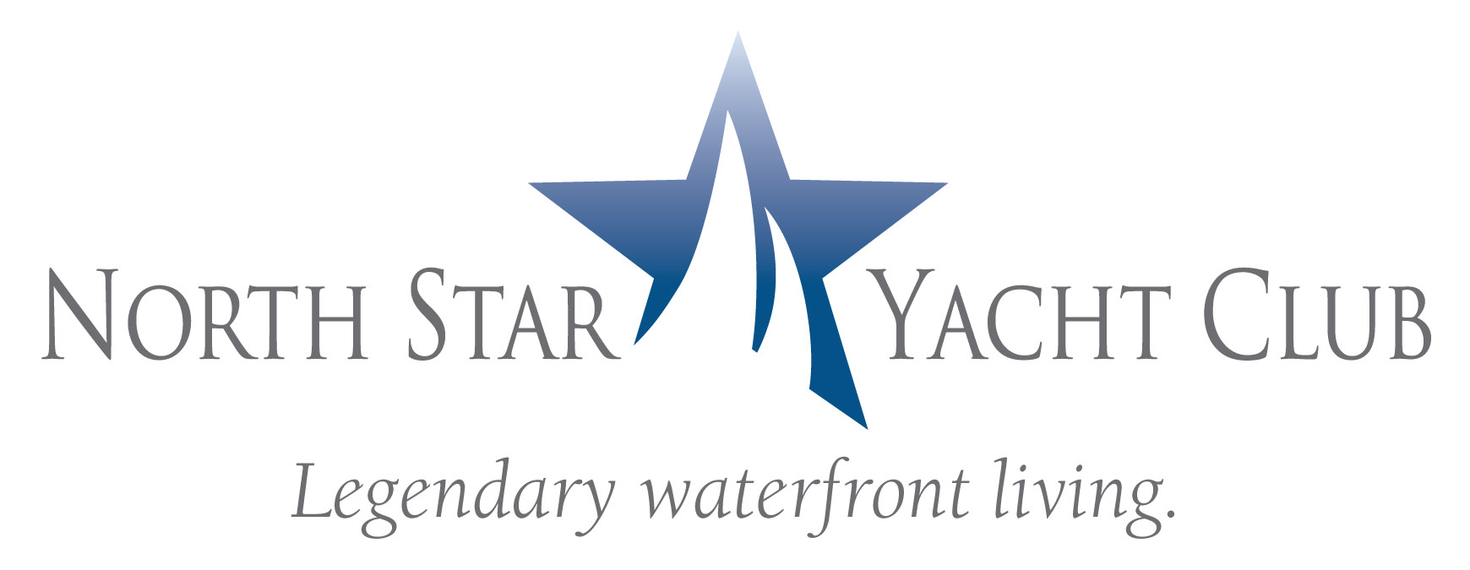

NORTH STAR YACHT CLUB’S NEW WEBSITE LAUNCHED

FORT MYERS, Fla. – September 24, 2008 – North Star Yacht Club, twin 12-story high rises with penthouse level located along the Caloosahatchee River in North Fort Myers, has launched a new web site showcasing the recently-completed property’s residences, amenities and services.

The new web site, www.NorthStarYachtClub.com, offers prospective buyers the ability to tour the 12-acre property online and view floor plans, standard features list, photo gallery, upcoming events and area information. The waterfront condominium residences, including a penthouse level, are currently being offered from the low $400,000s.

North Star Yacht Club is located at 3420 Hancock Bridge Parkway in North Fort Myers. The sales center and model residences are open Monday through Friday from 10:00 a.m. to 6:00 p.m., Saturday from 10:00 a.m. to 5:00 p.m., and Sunday noon to 5:00 p.m. For more information, call (239) 995-8200.

####

