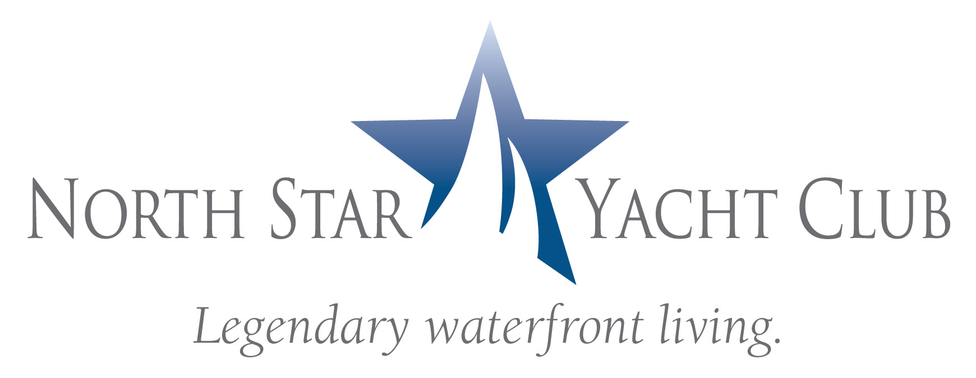

FOR IMMEDIATE RELEASE
Contact: Phyllis Ershowsky, PKE Marketing & PR Solutions
239.565.5996
phyllis@pkecreative.com

NORTH STAR YACHT CLUB KICKS OFF SEASON WITH
MOTIVATING SPEAKER
REALTOR® Event Focuses on Overcoming Market Circumstances & Generating Sales

NORTH FORT MYERS, FL –(August 31, 2009) – On Tuesday, September 22 at 9:30 a.m. North Star Yacht Club will kick off the 2009-2010 real estate sales season with a high-powered event featuring renowned sales trainer, consultant and author Jason Forrest, president of ShoreSelect (www.ShoreSelect.com).

Area REALTORS® will be invited to a light brunch reception followed by Forrest’s presentation which is designed to motivate sales teams to:
*Tap in to the REAL reason people buy homes
*Convert “just looking buyers” into sales
*Overcome market circumstances and take control of success
“Real estate professionals nationwide pay $100 or more to attend Jason’s seminars,” said Sam Morgan, vice president of sales for The Marketing Directors, LLC, the exclusive sales and marketing agent for North Star Yacht Club. “We are delighted to offer this program to the local real estate community at no charge to kick start what promises to be a much improved, active real estate market for the upcoming year.”

For more information, or to reserve a seat at this limited seating event, call
(239) 995-8200 or visit www.NorthStarYachtClub.com.

More about Jason Forrest, president, ShoreSelect
Accomplished sales trainer, consultant and author, Forrest’s passion is transforming sales representative into high-performance sales athletes. He spends his time tele-coaching sales managers, division presidents and company owners on how to overcome tough market challenges.

Formerly National Director of Sales Development for MDC Holdings/Richmond American Homes, Forrest holds an MBA in marketing, a degree in psychology, and a “Certified New Homes Sales Professional” designation from the NAHB. He is also the author of Creating Urgency in a Non-Urgent Housing Market, and 40-Day Sales Dare for New Home Sales to be released this fall. Together with his partner Jeff Shore, he is the co-creator of Leadership Selling® and Leadership Selling® for Coaches, a 33-week blended learning training curriculum for new home sales.

More about North Star Yacht Club
North Star Yacht Club, twin 12-story high rises with penthouse level located along the Caloosahatchee River in North Fort Myers, offers luxury riverfront condominium residences available for immediate occupancy.

Offering an upscale lifestyle, residents have exclusive access to a myriad of indoor and outdoor amenities, activities and services including an expansive clubhouse with theater, health club, business center, and resort-style pool. The 12-acre property also boasts a private marina walk and adjoining boat slips.

North Star Yacht Club is located at 3420 Hancock Bridge Parkway in North Fort Myers. The sales center and model residences are open Monday through Friday from 10:00 a.m. to 6:00 p.m., Saturday from 10:00 a.m. to 5:00 p.m., and Sunday noon to 5:00 p.m.

More about The Marketing Directors, LLC
The Marketing Directors, LLC is the exclusive sales and marketing agent for North Star Yacht Club. The Marketing Directors, LLC, based in Atlanta, GA was founded in 2007 by national condominium expert, David Tufts. He and Adrienne Albert, Marketing Directors, Inc’s Chief Executive Officer collaborated to create a team of the most highly experienced real estate professionals in the Southeast to service developers specializing in high density residential sales and marketing. With over 30 years of experience, The Marketing Directors is well positioned to be the solution to developers in any market condition. The Marketing Directors, LLC represents developers in Atlanta, Orlando, Tampa, West Palm Beach St Petersburg, Chapel Hill, and Huntsville.

For more information or to register for the Jason Forrest Presentation, call 239-995-8200.

####
(headshot of Jason Forrest)
National sales trainer and author Jason Forrest will be the guest speaker at North Star Yacht Club in September.

